****Branch of “Nazarbayev Intellectual Schools” AEO Nazarbayev Intellectual School of Physics and Mathematics in Uralsk

**“TumoBrainor” – application for detecting and classifying brain tumors**

*School:* Nazarbayev Intellectual School of Physics and Mathematics in Uralsk  
*Team members:* Seidazymov Adil Kanatovych, Khussainov Marat Timurovich, 10A

*Section:* 2, Computer Programming

*Heads*: Tlekkabylova Dinara Zharkinovna, Suleimenova Aisulu Arystanovna

Astana, 2023

Content

Abstract 2

Introduction 3

Research 5

Problem review 5

Incidence and Mortality Rates 5

Survival rate 5

Epidemiology of Brain Tumors in Different Social Groups 6

Age 6

Race/Ethnicity 8

Sex 8

Economical cost 9

Physical and Mental symptoms 10

Methods of treatment 10

Detection and classification of brain tumors 11

Need for Further Research: 12

Problem solving methods. 14

Results and discussions 16

Results 16

Discussions 17

Conclusion 18

References 19

# Abstract

Our research aimed to develop an app that uses AI to detect and classify brain tumors and provides statistical analysis based on users’ data. Our hypothesis is that AI algorithms can accurately analyze medical images and provide valuable insights into the prevalence and characteristics of brain tumors. We divided the study into four stages: app development, data collection and preprocessing, model development and training, testing and evaluation. Our AI model was developed using deep learning techniques and trained on a dataset of brain scans collected from public sources. We evaluated our model against benchmarks and compared its performance with that of human experts.

Our study is novel because it provides user-friendly interface that allows users to easily upload brain scans and receive quick and accurate results. Additionally, the app includes a built-in feature for guiding users on next steps, such as contacting medical professionals for further evaluation. Furthermore, the app's statistical analysis feature provides valuable information, potentially leading to better understanding and treatment of the condition.

The research was conducted independently by undergraduate students under the supervision of experienced researchers. Our results showed that the AI model has a high accuracy rate in detecting brain tumors and the statistical analysis based on user data can provide valuable insights into the prevalence and characteristics of brain tumors. In summary, our study highlights how AI-powered apps can improve the precision and speed of medical diagnoses while providing significant information on medical conditions.

# Introduction

Brain tumors are a significant health concern in Asia, with a high impact on individuals and society. According to data from the International Agency for Research on Cancer (IARC), an estimated 166,925 new cases of brain tumors were diagnosed in Asia in 2020, accounting for about 54% of all new cases globally (IARC, 2020). The incidence of brain tumors in Asia varies by country, with the highest incidence rates reported in Japan, Korea, and Taiwan (IARC, 2020).

Brain tumors can affect people of all ages but are most common in older adults. In Asia, the incidence of brain tumors increases with age, with the highest incidence rates reported in individuals over 65 years of age (IARC, 2020). Additionally, brain tumors are a leading cause of cancer-related deaths in Asia, accounting for 3.9% of all cancer deaths in the region (IARC, 2020).

The impact of brain tumors on individuals and society in Asia is significant. Brain tumors can cause a wide range of symptoms, including headaches, seizures, cognitive impairments, and motor deficits, which can impact the quality of life of affected individuals.

The goal of this work is to develop an artificial intelligence (AI)-based system to detect and classify brain tumors using MRI scans. The system provides an automated, data-driven approach to identifying and categorizing brain tumors to aid radiologists and oncologists in diagnosis. The AI system utilizes machine learning algorithms trained on a dataset of MRI scans labeled with the location and type of brain tumors.

Once trained, the AI system can analyze new MRI scans and provide information about any detected tumors, including:

- A classification of the tumor type (e.g., glioma, meningioma, metastasis) based on radiomic features like shape, texture, and intensity

- Statistics on the types of tumors identified in recent analyses to inform physicians on the epidemiology of specific tumor presentations.

The key methods employed are machine learning techniques such as convolutional neural networks (CNNs) for image analysis and classification. CNNs can automatically learn patterns in large datasets of medical images to identify brain tumors. A user-friendly web interface allows physicians and healthcare providers to easily upload MRI scans to the AI system and view the results of the analysis, including a visualization of any detected tumors on the scans.

This work demonstrates the significant potential of AI and machine learning for improving brain tumor diagnosis and prognosis. By providing fast, objective, and accurate detection and classification of brain tumors on MRI, this system can help physicians diagnose patients earlier, determine optimal treatment plans, and improve outcomes. The statistics on tumor types can also inform future research on tumor epidemiology and etiology.

While promising, the system has some limitations. The machine learning models rely on the dataset used for training and may not generalize well to various scans. The system also cannot match the reasoning, intuition, and experience of human radiologists. However, this AI system can act as a tool to assist physicians in evaluating MRI scans and help reduce errors or variability in diagnosis between different radiologists.

With further research, integration of more advanced imaging modalities, and training on larger datasets, the performance of machine learning models for brain tumor diagnosis can continue to improve. AI and machine learning have the potential to significantly enhance diagnosis and prognosis in the healthcare domain. Systems like this demonstrate the meaningful impact that AI can have on improving patient outcomes and healthcare productivity.

# Research

## Problem review

### Incidence and Mortality Rates

Brain tumors are the 12th most deadly form of cancer, according to the World Health Organization (WHO). In 2020, brain tumors claimed the lives of 251,329 people worldwide (WHO, 2020). These tumors can affect people of all ages, from children to the elderly. The incidence and mortality rates of brain tumors vary by country, with some nations reporting higher rates than others.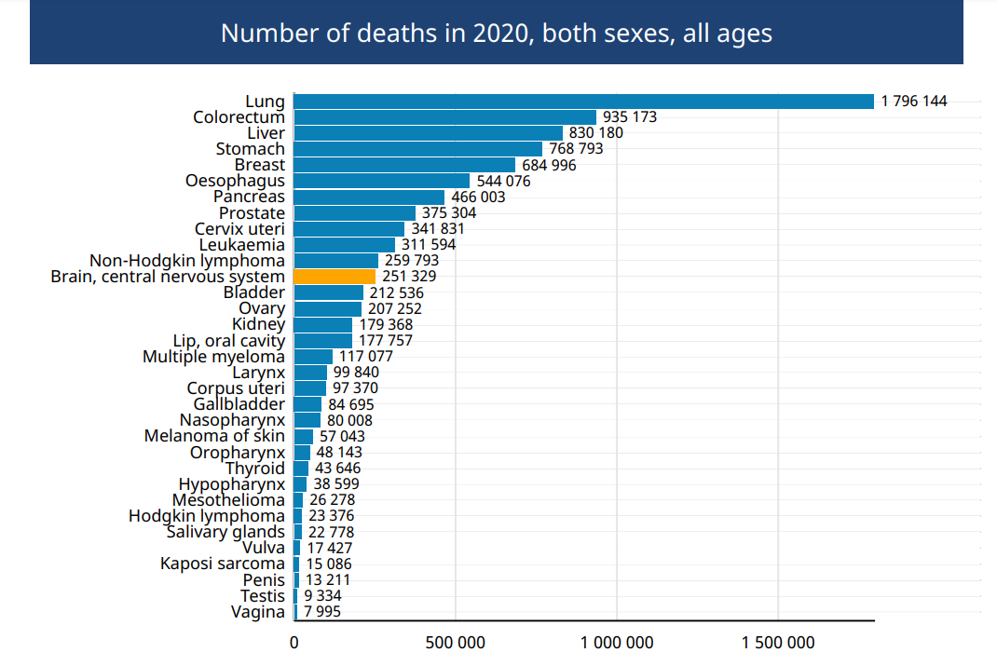

Figure 1. The number of deaths from cancer, WHO, 2020

Globally, the incidence rate of brain tumors is 3.4 per 100,000 people, and the mortality rate is 2.5 per 100,000 people. However, these rates are not uniform across countries. Albania has the highest incidence rate of neurological cell death among all nations, with an incidence of 10.4 and a death rate of 7.5 per 100,000 people. These statistics indicate a significant problem in Albania and highlight the need for more research to improve patient outcomes.

### Survival rate

While survival rates have progressed gradually, brain tumor survival remains poor overall, especially for aggressive high-grade tumors. Disparities exist, and survival could be far better with breakthrough research progress against this deadly disease.

The below statistic[1] shows a modest but steady increase in 5-year relative survival rates for brain cancer over the past few decades in USA. In the late 1970s, the 5-year relative survival rate was only 23%, indicating poor long-term prognosis and survival odds. However, by the mid-1990s, the rate increased to 32%, suggesting some improvements in treatment and outcomes. While the increase from the 1990s to 2012-2018 was more marginal, rising to 33%, there has been a gradual upward trend overall in how people with brain cancer are surviving up to 5 years after diagnosis.

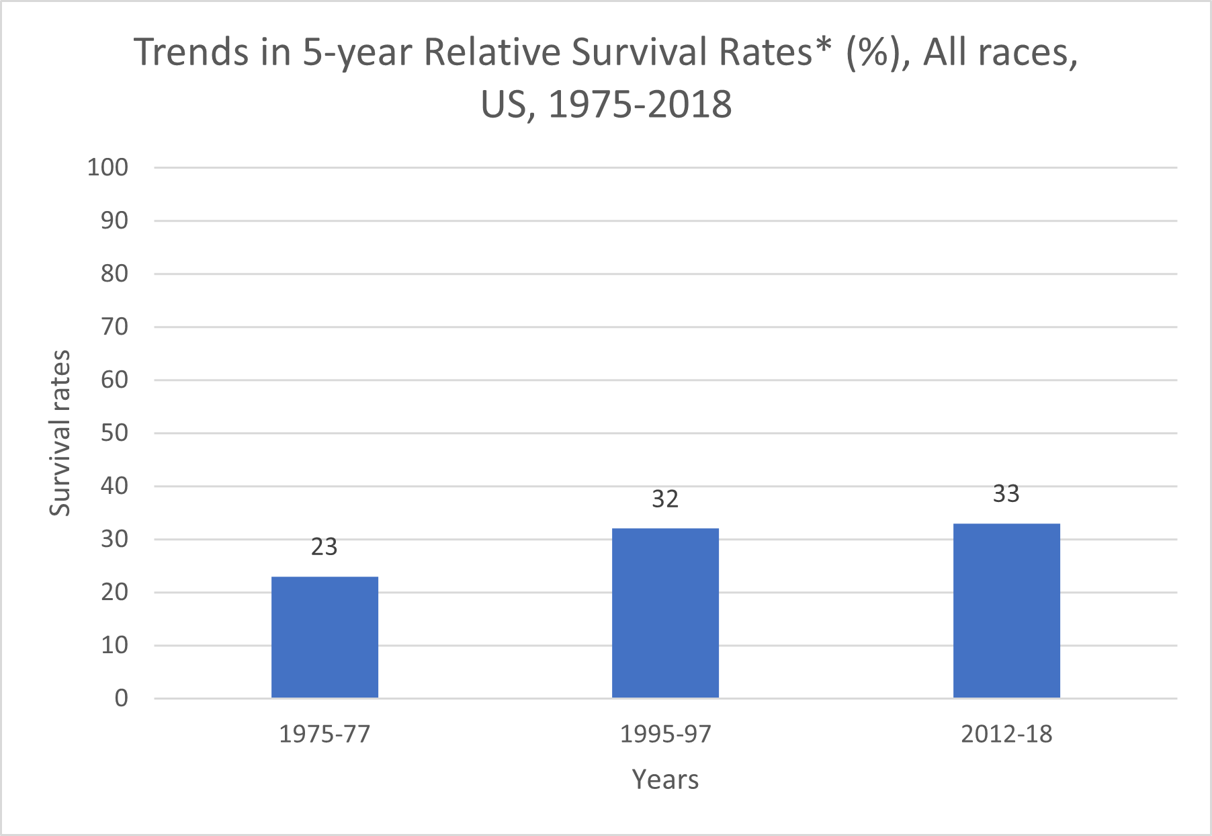

Figure 2. Trends in 5-year Relative Survival Rates, American Cancer Society, Cancer Facts & Figures 2023

Despite this progress, the 5-year survival rates remain low, highlighting how brain cancer continues to be an aggressive and difficult to treat type of cancer. More breakthroughs are needed to achieve dramatically better long-term survival outcomes. The slow but steady gains over time also suggest that improvements in treatment have been incremental, rather than revolutionary. Ongoing research on new therapies like immunotherapy, targeted drug treatments, and improving existing treatments like surgery, radiation and chemotherapy are helping to extend more lives, but brain cancer remains an immense challenge.

### Epidemiology of Brain Tumors in Different Social Groups

While brain tumors can affect individuals of any age, gender, ethnicity, or socioeconomic status, the impacts of brain tumors are disproportionately felt by certain groups based on factors like age, race, and sex.

#### Age

Brain tumors can affect people of all ages, but they are most commonly diagnosed in adults over the age of 60. According to the National Brain Tumor Society, the median age at diagnosis for a primary brain tumor is 61 years**,** age-specific incidence rates for primary brain tumors are highest among those age 85+.In the following graphic the age of individuals is brokendown into four categories: children, adolescents (15-19), adolescents and young adults (15-39), and adults (40+).

The data shows that brain tumors are relatively rare in children, with only 3.9% of cases occurring in this age group. The incidence of brain tumors then increases in the adolescent age group (15-19), where 1.7% of cases are reported. However, brain tumors are the most common cancer and pediatric brain tumors are the leading cause of cancer-related death among children and adolescents ages 0-19 years. It was estimated in 2009, that a total of 47,631.5 years of potential life were lost due to brain tumors in children and adolescents in the US

Figure 3. The distribution of brain tumor cases across different age groups

The largest proportion of brain tumor cases are reported in the adult age group (40+), where 81.7% of cases occur. This suggests that brain tumors are most commonly diagnosed in older adults.

The data also shows that a significant proportion of brain tumor cases occur in the adolescent and young adult age group (15-39), with 14.3% of cases reported in this category. This highlights the importance of considering brain tumor risk and prevention strategies for individuals in this age range.

Figure 4. Five-year relative survival rate across different age groups

The data presented describes the five-year relative survival rates for primary and malignant brain tumors in different age groups. The data is broken down into three categories: children (0-14), adolescents and young adults (15-39), and adults (40+).

The data shows that the five-year relative survival rate for all primary brain tumors is generally high across all age groups. Children (0-14) have a five-year relative survival rate of 83.10%, while adolescents and young adults (15-39) have an even higher five-year relative survival rate of 90.90%. Adults (40+) have a slightly lower five-year relative survival rate of 72.50%.

In contrast, the five-year relative survival rate for all malignant brain tumors is generally lower across all age groups. Children (0-14) have a five-year relative survival rate of 75.60%, while adolescents and young adults (15-39) have a slightly lower five-year relative survival rate of 71.70%. Adults (40+) have the lowest five-year relative survival rate for malignant brain tumors, at only 21%.

These data suggest that survival rates for primary brain tumors are generally higher than those for malignant brain tumors. Additionally, the data highlights the importance of considering age as a factor in brain tumor survival rates, as the survival rates vary across different age groups.

#### Race/Ethnicity

The incidence rates of primary brain tumors vary across different racial and ethnic groups. Research indicates that people who are Black have slightly higher incidence rates of primary brain tumors compared to other races, followed by people who are White, APIA[2], and AIAN[3].

The incidence rates of non-malignant brain tumors are highest in people who are Black, followed by people who are White, APIA, and AIAN. In contrast, incidence rates of malignant brain tumors are highest in people who are White, followed by people who are Black, AIAN, and Asian/Pacific Islander.

It is important to note that incidence rates for specific brain tumor types can vary significantly across racial and ethnic groups. It can be exemplified by fact that individual who are White have significantly higher incidence rates for glioblastoma, all other astrocytomas, embryonal tumors, and nerve sheath tumors compared to people who are Black. Another instance is that individual who are Black have higher rates of meningioma and pituitary tumors compared to people who are White.

Overall incidence rates of brain tumors are higher in people who are non-Hispanic than people who are Hispanic.

#### Sex

There may be a sex-specific pattern in the incidence rates of different types of primary brain tumors. Further research is needed to understand the underlying factors that contribute to these differences.

For example, primary brain tumors are more commonly diagnosed in females, with 58.7% of cases occurring in women. In contrast, 41.3% of primary brain tumor cases are reported in men.

Figure 5. Incidence rates across sexes

The below graph shows a notable difference in incidence rates between non-malignant and malignant primary brain tumors in males and females. Non-malignant primary brain tumors are more commonly diagnosed in females, with 64.4% of cases occurring in women, while 35.6% of cases occur in men. In contrast, malignant primary brain tumors are more commonly diagnosed in males, with 55.8% of cases occurring in men, while 44.2% of cases occur in women.

### Economical cost

The financial costs faced by brain tumor patients can be significant and wide-ranging, impacting both the individual and the health system. For individuals, the costs of a brain tumor can include loss of income, higher domestic bills, and costly home modifications. In the UK, the average household affected by a brain tumor is financially worse off by £14,783 per year, compared to £6,840 for all cancers.

Treating brain tumors is also expensive for health systems. In the UK, where Brain Tumour Research works, brain cancer has a relatively high direct medical cost, which includes costs associated with hospital visits, drugs, and staff time. The average in-patient, post-diagnosis costs for brain tumors are £13,200, higher than breast, lung, and prostate cancers. However, the direct medical costs can vary dramatically depending on the type of brain tumor, of which there are more than 120. For those with a higher-grade malignant tumor, the approximate direct medical cost for a year can be as high as £180,000.

While direct medical costs are a significant burden, the indirect costs of brain tumors can be even greater, including the costs associated with providing patients with various social services and benefits, as well as losses of tax revenue. The economic costs of brain tumors among working-age people have been estimated at £578 million per annum in the UK, ranking third highest amongst more common cancers behind lung (£1.2 billion) and breast (£635 million). These indirect costs also include social losses, which account for the lost value of informal care, volunteering, and domestic spending. In addition, the total cost of brain tumors in the United States is estimated to be $4.77 billion annually (Cancer.net, 2021).

Overall, these data highlight the significant financial burden of brain tumors on both individuals and society as a whole. This figure highlights the need for further research into brain tumors to improve treatment options and reduce the economic impact on patients and their families. Research into brain tumors can help to improve treatment options, reduce healthcare costs, and improve the quality of life for patients and their families.

### Physical and Mental symptoms

Brain tumors can have a significant impact on the lives of patients, their families, and society as a whole. Patients with brain tumors may experience physical and cognitive disabilities, leading to reduced life expectancy and significant disability. The physical symptoms of brain tumors can vary depending on the location and size of the tumor. Some of the common physical symptoms of brain tumors include:

* Headaches: Brain tumors can cause persistent headaches that may worsen over time, especially in the morning or when lying down.
* Seizures: Seizures can be caused by abnormal electrical activity in the brain and can be a symptom of brain tumors.
* Nausea and vomiting: Brain tumors can cause nausea and vomiting due to increased pressure inside the skull.
* Weakness or numbness: Brain tumors can cause weakness or numbness on one side of the body or in a specific part of the body, depending on the location of the tumor.
* Changes in vision or hearing: Brain tumors can cause changes in vision or hearing, including blurred vision, double vision, or hearing loss.
* Difficulty with balance or coordination: Brain tumors can affect the areas of the brain that control movement and coordination, causing difficulty with balance and coordination.
* Changes in speech or language: Brain tumors can affect the areas of the brain that control speech and language, causing difficulty with communication.

The treatment of brain tumors can be expensive, and patients may require ongoing care and support. Brain tumors can also impact productivity, with patients being unable to work or needing to take time off to receive treatment.

In addition to the physical impact, brain tumors can also cause significant emotional distress to patients and their families. Patients with brain tumors often experience anxiety, depression, and other mental health issues, which can have a profound impact on their quality of life.

### Methods of treatment

Current treatments for brain tumors include surgery, radiation therapy, and chemotherapy, but these treatments can have significant side effects and may not be effective for all patients. In recent years, these methods are only getting better, but it's worth going over each of them briefly.

* Surgery is often the first line of treatment for brain tumors, and advances in surgical techniques and technology have improved outcomes for many patients. However, surgery can be challenging due to the location and size of the tumor, and there is a risk of damage to healthy brain tissue during the procedure. In addition, not all brain tumors can be removed surgically, and the risks of surgery may outweigh the benefits in some cases.
* Radiation therapy is often used in combination with surgery or as a stand-alone treatment for brain tumors. While radiation therapy can be effective in killing cancer cells, it can also damage healthy brain tissue and cause side effects such as fatigue, nausea, and hair loss. In addition, radiation therapy may not be effective for all types of brain tumors, and the optimal dose and duration of treatment are still being studied.
* Chemotherapy is a systemic treatment that uses drugs to kill cancer cells throughout the body. While chemotherapy can be effective in treating some types of brain tumors, it can also cause significant side effects such as nausea, hair loss, and an increased risk of infection. In addition, chemotherapy may not be effective for all types of brain tumors, and there is a risk of the tumor becoming resistant to the drugs over time.
* Targeted therapies are a newer type of treatment that aim to attack cancer cells while minimizing damage to healthy cells. These therapies work by targeting specific molecules or pathways that are important for the growth and survival of cancer cells. While targeted therapies have shown promise in other types of cancer, their effectiveness in treating brain tumors is still being studied. In addition, targeted therapies may have side effects such as skin rash, diarrhea, and liver damage.

Current treatments for brain tumors have limitations, and there is a need for more effective and less toxic treatments. However, at the moment there are very often cases of misdiagnosis of brain tumors, or on the contrary, doctors miss the signs of it. And given what was said earlier, this further increases the impact of tumors on a person, forcing them to undergo harmful procedures for the body several times over. From this comes the need for the introduction of computer technology, such as neural networks, into medicine.

### Detection and classification of brain tumors

Magnetic Resonance Imaging (MRI) is a crucial tool in the diagnosis of brain tumors, as it provides detailed images of the internal structures of the brain. The MRI machine uses a strong magnetic field and radio waves to create images that show any abnormalities or signs of a tumor in the brain.

When analyzing the images, radiologists and neurologists pay close attention to the signs of the tumor itself. These signs include areas of abnormal tissue that appear brighter or darker than the surrounding tissue, as well as any distinct shapes or borders that may indicate the presence of a tumor. By examining these signs, doctors can classify the tumor's type and location, which helps determine the best course of treatment for the patient.

In some cases, a contrast agent may be used to highlight the tumor and provide more information about its size and location. However, even without contrast enhancement, an MRI can often reveal the presence of a brain tumor and provide valuable insights into its characteristics.

If a brain tumor is suspected, further testing such as a biopsy or functional MRI may be necessary to confirm the diagnosis and determine the extent of the tumor. Overall, the signs of the tumor itself, as detected through MRI imaging, are critical in the diagnosis and treatment of brain tumors.

Once a brain tumor has been detected through MRI imaging, the radiologist or neurologist will classify the tumor based on its characteristics. There are several different types of brain tumors, including gliomas, meningiomas, pituitary tumors, and acoustic neuromas.

The classification of a brain tumor is important because it helps doctors determine the best treatment approach. For example, some tumors may require surgery, while others may be treated with radiation therapy or chemotherapy.

The classification of a brain tumor is based on several factors, including the type of cells that make up the tumor, its location in the brain, and how fast it is growing. For example, gliomas are tumors that arise from the glial cells in the brain, while meningiomas are tumors that arise from the meninges, the protective layers that surround the brain.

In addition to classifying the type of tumor, doctors also need to determine its location in the brain. This information is important because it helps doctors understand the potential impact of the tumor on the patient's brain function. For example, a tumor in the motor cortex of the brain may affect a patient's ability to move their limbs.

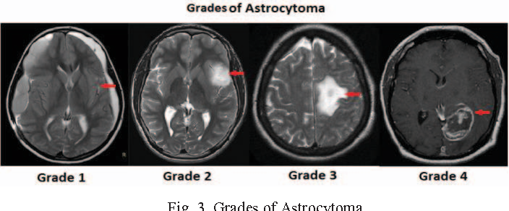Finally, doctors need to determine how fast the tumor is growing, which is referred to as its grade. Brain tumors are graded on a scale of 1 to 4, with grade 1 tumors being the least aggressive and grade 4 tumors being the most aggressive.

Figure 6. Brain tumor graders

Overall, the classification of a brain tumor based on its type, location, and grade is critical in determining the most appropriate treatment approach for the patient. MRI imaging plays a crucial role in this process by providing detailed images of the tumor that can be used to make these important diagnostic decisions.

### Need for Further Research:

The prognosis for patients with brain tumors remains poor, despite the advances in treatment. Further research into brain tumors is significantly needed to enhance patient outcomes and treatment options. Identifying preventative measures through research into the causes of brain tumors is essential in reducing their incidence. Exposure to radiation is one of the identified risk factors for brain tumors. The causes of brain tumors, however, are still not fully understood. Identifying new treatment options and preventative measures requires further research into the genetic and environmental factors that contribute to the development of brain tumors.

Research is also needed to improve the accuracy of brain tumor diagnoses. Accurate diagnoses are essential for selecting the most effective treatment options for patients. Advanced imaging techniques and molecular testing can help improve the accuracy of brain tumor diagnoses, but more research is needed to refine these techniques and make them more widely available.

In addition, research is needed to develop new treatment options for brain tumors. Current treatments include surgery, radiation therapy, and chemotherapy, but these treatments can have significant side effects and may not be effective for all patients. Research into targeted therapies and immunotherapy may lead to more effective and less toxic treatment options for brain tumors.

That is why brain tumors are a significant medical condition that can have a profound impact on patients, their families, and society as a whole. The incidence and mortality rates of brain tumors vary by country, highlighting the need for further research into this area. The economic impact of brain tumors can be significant, and patients and their families require ongoing care and support.

Research into brain tumors is necessary to improve treatment options, reduce healthcare costs, and improve the quality of life for patients and their families. Advances in imaging techniques, molecular testing, and treatment options may lead to more effective and less toxic treatments for brain tumors. Increased funding for brain tumor research is necessary to address this significant medical condition and improve patient outcomes.

In summary, brain tumors are a complex and devastating medical condition that requires further research to improve patient outcomes and reduce the economic impact on patients and their families. The incidence and mortality rates of brain tumors vary by country, highlighting the need for targeted research in areas with high rates. Increased funding for brain tumor research is necessary to address this significant medical condition and improve patient outcomes.

## Problem solving methods.

We chose convolutional neural networks (CNN for short) for this project due to their effectiveness in image recognition and classification tasks. CNNs are specifically designed to process and classify images, which makes them ideal for detecting and classifying brain tumors from medical images. They can learn features from images through multiple layers of convolution, pooling, and non-linear activation functions, making them well-suited to the task at hand.

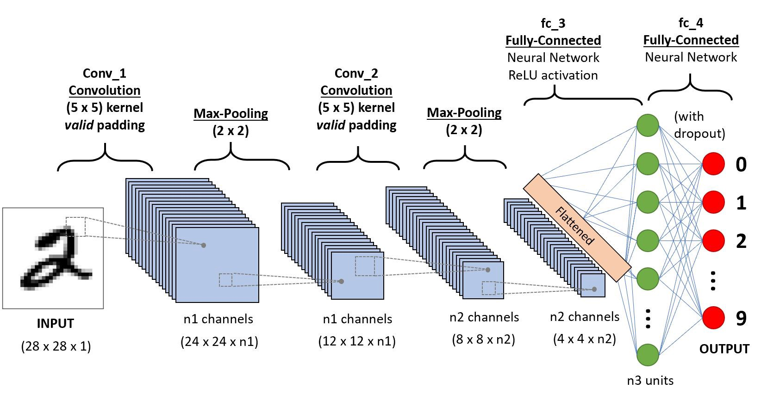Convolutional neural networks (CNNs) are made up of several layers, each of which performs a unique task. The first layer is the input layer, which takes the raw image data as input. The subsequent layers are convolutional layers, which apply a set of filters to the input image. Each filter is small in size and slides over the entire input image, producing a feature map for each filter.

Figure 7. Convolutional Neural Network Architecture

The output of each convolutional layer is then passed through a non-linear activation function, such as ReLU, which introduces non-linearity into the model. The output is then down sampled using a pooling layer, which reduces the spatial dimensions of the feature maps.

Finally, the output of the convolutional layers is passed through one or more fully connected layers, which combine the learned features into a single vector that can be used for classification.

For this project, we used ResNet50, which is a deep CNN architecture that has achieved state-of-the-art performance in various image classification tasks. ResNet50 is a 50-layer neural network that uses skip connections to address the issue of vanishing gradients in deep neural networks. The skip connections allow information to bypass several layers of the network, allowing for better information flow and improved training of the model. This architecture has proven to be effective in improving the performance of deep neural networks, making it an ideal 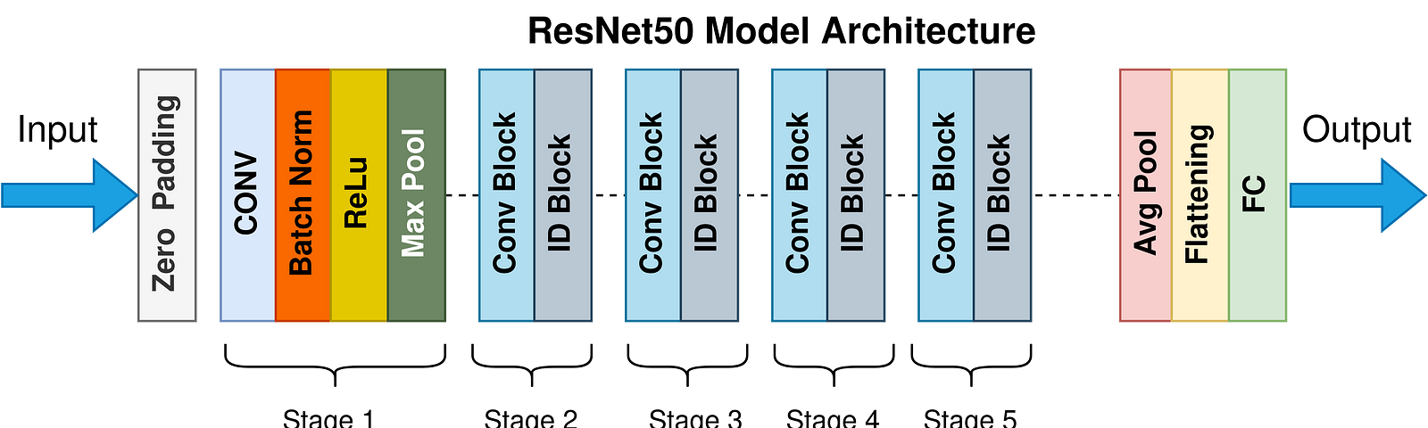choice for brain tumor classification.

Figure 8. ResNet50 Model Architecture

To implement our own model, we have chosen the Python programming language due to its exceptional features in the field of machine learning. Python has a rich ecosystem of machine learning libraries such as Scikit-learn, TensorFlow, Keras, and PyTorch. These libraries provide a high-level API for implementing and training various types of machine learning models, including CNNs. They also offer support for common machine learning tasks such as data preprocessing, hyperparameter tuning, and model evaluation.

In particular, the Python libraries NumPy, Pandas, and Matplotlib are widely used in machine learning applications. NumPy provides efficient numerical computation for large datasets, while Pandas is a data manipulation library used for data preprocessing. Matplotlib is a powerful data visualization tool used to create high-quality plots and graphs. These libraries, along with others, make Python a versatile language for data analysis and machine learning. Python's simplicity and readability make it an ideal language for quick prototyping and experimentation. Python's interactive programming environment, Jupyter Notebook, enables data scientists to test and refine machine learning models in real-time.

The integration of Python with the TensorFlow framework made it an excellent choice for our project. TensorFlow is an open-source software library developed by Google Brain that offers high-level APIs for building and training machine learning models, including CNNs. It provides a vast array of features such as a powerful computation engine, distributed training, and automatic differentiation. It is designed to be scalable, making it suitable for large-scale data processing and modeling. Moreover, TensorFlow supports various programming languages, including Python, making it highly accessible to data scientists and developers.

Our CNN model was trained using the brain tumor dataset posted by Jum Cheng on figshare.com. The dataset consisted of MRI images of brain tumors, including glioma, meningioma, and pituitary tumors, along with corresponding labels for each image.

The preprocessing step involved resizing the images to a standard size and normalizing the pixel values to a range between 0 and 1. The model was trained for 30 epochs using the Adam optimizer and categorical cross-entropy loss function. Data augmentation techniques such as rotation, flipping, and zooming were employed to increase the size of the training set and improve the model's generalization. Additionally, early stopping was implemented to prevent overfitting of the model.

## Results and discussions

### Results

The brain images were separated for training (70%), validation (20%), and testing (10%) of the model. The process of model training and validation was repeated until model accuracy reached approximately 100%. The following graph shows how as epochs (generations) increase, the accuracy of the model increases in both training and validation and reaches approximately 100% at the end.

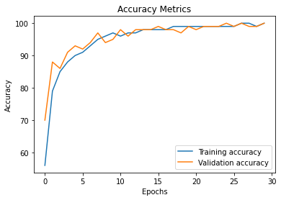

Figure 9. Accuracy of the model during training and validation

The program was further tested on a test dataset, where it showed an accuracy of 98.7%. Also, the program was mostly correct in classifying the tumor when it was detected. The below graph shows that the correspondence between the diagnosis and the real diagnosis is quite high, and the number of incorrect diagnoses is relatively low.

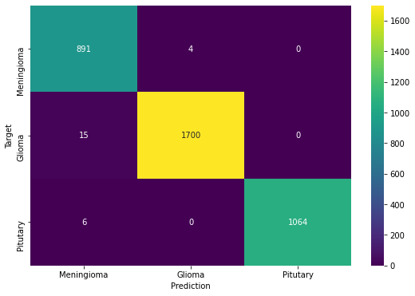

Figure 10. Confusion Matrix on Test set

While the program can detect tumors and determine their likely classification, it currently cannot segment tumor areas or estimate additional characteristics. However, the program has an intuitive interface allowing easy uploading of MRI scans, viewing of detection/classification results, access to summary statistics, and guidance on recommended next steps (contacting medical professionals for further evaluation).

The program shows significant potential to assist radiologists and neurologists in analyzing brain MRIs, initially for detecting and classifying suspicious lesions. With continued improvement, the AI could ultimately support more in-depth analysis and diagnosis.

### Discussions

This AI system provides substantial benefits for streamlining and augmenting the interpretation of brain scans to identify tumors. By aiding in detection and initial classification, the program could help radiologists focus their expertise and time on the scans requiring the most complex review. For many straightforward cases, the AI may provide a "second set of eyes" with a different perspective than human experts.

However, the program is still limited in its capabilities. It cannot currently segment the tumor area or estimate other characteristics like size, stage, or grade. The program can only provide initial detection and classification results—medical professionals would still need to evaluate the scans and any additional tests required for diagnosis and treatment. The program also cannot detect very rare or anomalous tumor types as it was trained on the most common types. Ongoing training and development would be needed to expand its capabilities, especially as medical knowledge and imaging technologies continue to advance.

Comparisons of the AI's performance to experienced radiologists will also be crucial for validating the program and identifying any remaining errors or limitations before broad clinical application. With a proven record of success and ability to enhance radiologists' work instead of replacing it, the AI could spread to hospitals, clinics, and private practices, empowering earlier and more accurate detection and treatment of brain tumors.

Overall, this AI system demonstrates how machine learning can positively transform healthcare by supporting specialists, streamlining processes, reducing delays and human errors, and improving patient outcomes. Further developing and implementing this technology responsibly has tremendous promise for the field of radiology and cancer treatment.

With further refinement and validation, this AI-based tool shows promise to serve as an initial screening and triage system to help prioritize urgent cases, reduce wait times, and allow medical professionals to focus their time on more complex tasks. However, human expertise and judgment will still be essential for diagnosis and treatment. AI should serve to augment human capabilities, not replace them.

# Conclusion

**Summary of Main Results:**

•An AI-based program achieved 98.7% accuracy in detecting and classifying glioma, meningioma, and other brain tumors using MRI scans.

•The program can detect and classify tumors but cannot yet segment tumor areas or estimate characteristics.

•The program features an intuitive interface allowing users to upload scans, view results, access statistics, and get guidance on next steps (contacting medical professionals).

**Implications and Recommendations**:

This AI has significant potential for assisting radiologists and neurologists in analyzing brain MRIs, especially for initial detection and classification of concerning lesions. With continued improvement, the AI could support more detailed analysis and diagnosis over time.

To improve the program's practical application:

Include only the cropped MRI brain scan image, removing unnecessary details to aid the AI's image analysis.

Achieve the highest accuracy for high-resolution (minimum 480p) and high-quality scans. This allows the neural network to better distinguish brain/tumor boundaries and provide more accurate results than poor quality images.

* Meaningfully name each image (e.g. patient name) for easier database navigation.
* Ask neurologists to evaluate sample results/statistics and validate accuracy before broad use.
* Consider options to adjust detection boxes, exclude false positives, customize the network for tumor types, train on larger/more diverse datasets, and compare results to radiologists.
* Build in safeguards like requiring user confirmation before taking action based on results.
* Enhance real-world applicability by validating on radiologist comparisons, training on larger data, and customizing for specific tumor types.

The program shows significant promise for assisting with brain tumor analysis and diagnosis. With focused improvements, continued accuracy evaluation, and integration of expert feedback, this AI could provide substantial benefits to patients and the medical system.

# References

* American Cancer Society. Cancer Facts & Figures 2023. Atlanta: American Cancer Society; 2023
* World Health Organization, The Global Cancer Observatory, 2020
* National Brain Tumor Society analysis, <https://braintumor.org/brain-tumors/about-brain-tumors/brain-tumor-facts/>
* Brain Tumor Research, The high price of brain tumours, Nick Perkins, 2020
* Central Brain Tumor Registry of the United States Fact Sheet for Pediatric Brain Tumors 2022, https://cbtrus.org/wp-content/uploads/2022/05/CBTRUS-Pediatric-Factsheet-2022.pdf

1. American Cancer Society, ‘Cancer Facts & Figures 2023’.
2. Asian, Pacific Islander
3. American Indian/Alaska Native